FRIENDLY REMINDER:
PLEASE TAKE TIME TO READ AND FOLLOW POOL RULES FOR EVERYONE'S SAFETY AND ENJOYMENT OF OUR COMMUNITY POOL
POOL IS NOW OPEN!
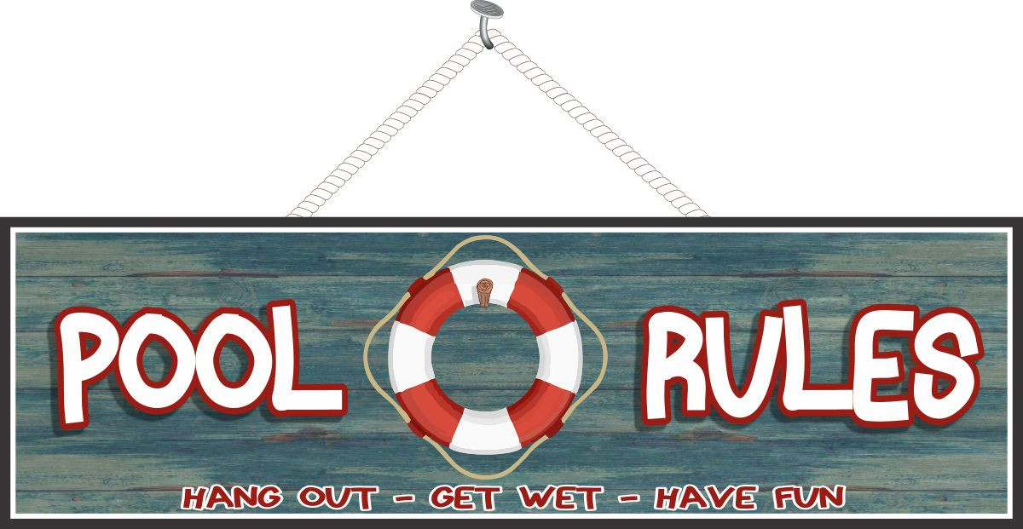
RULES GOVERNING MILFORD WOODS COMMUNITY POOL
1. You must use your validated pool access card to enter pool area. Jumping the fence/gate to gain entry is PROHIBITED.
2. Non-resident(s), not accompanied by a resident(s) are not allowed in pool area.
3. Resident(s) are to conduct themselves in a manner that is not threatening and/or disruptive to others in and around the pool. No running, jumping over others, grabbing, pulling others underwater, pushing others into pool, etc.; no yelling, screaming, playing loud music and/or with lyrics offensive to others and inappropriate for young children. Your behavior should never cause others, also entitled to pool privileges, to leave the pool area.
4. Children under the age of 14 are to be supervised at all times by an adult. You must be 18 years or older to supervise a minor.
5. Do not tamper with the First Aid Kit or the items within. It is for emergency use only.
6. Do not tamper with the Life Ring as it is for emergency use only. Leave it in its designated place.
7. No animals in pool area.
8. No glass allowed in pool area.
GUESTS
1. One (1) guest per one (1) residence. Contact Common Grounds chairperson/BOD as exceptions can be made under special circumstances.
2. The number of guest should not be so that they take over the entire pool. This also includes taking over an entire end of the pool.
3. Residents are to accompany their guest(s) to the pool and remain with them throughout the duration.
4. Guest(s) are to abide by all pool rules.
POOL RULES:
1. There should be no Solo Swimming.
2. There should be no running, boisterous or rough play.
3. No person under the influence of alcohol or drugs should use the pool.
4. There should be no spitting or blowing nose in pool.
5. Persons with communicable disease should not enter the pool.
6. Persons with skin, eye, ear or nasal infections should not enter the pool.
7. No animals or pets allowed in the pool.
8. No glass allowed in the pool or on the deck.
9. No children should be in the pool without supervision.
10. You should take a shower before entering the pool.
11. The Pool is Open from 7AM to 9PM.
12. The maximum number of swimmers allowed in the pool is 50.
13. A First Aid Kit is located at entrance way.
14. An Emergency Phone is located to the right of entrance way.
AREA IS MONITORED BY SECURITY CAMERAS
Open 7AM to 9PM
Children under 14 years old must be supervised by an Adult.
Anyone vandalizing the facility will be prosecuted.
Resident opening gate to unauthorized person:
1st Offense - A warning issued
2nd Offense - Pool key deactivated for Summer.

We thank you for your kind cooperation!
MILFORD WOODS BOARD OF DIRECTORS

Milford Woods Board of Directors: board@milfordwoods.com
Community Website: www.milfordwoods.com
Community Closed Group in Facebook: Milford Woods Community Homeowners

